Indian Liver Patient Data Report
Portfolio Project

Table of Contents
Introduction 1
Data Preparation & Cleaning 2
Steps 2
Implemention 3
Data Visualization & Descriptive Analysis 6
Steps 6
Practical 7
Other 10
Industry Application 11
Healthcare diagnostics & treatment 11
Conclusion 11
Key Takeaways 11
References 12

Introduction
This project demonstrates how R and RStudio can be used to perform an end-to-end data analytics workflow, including data preparation, cleaning, visualisation, and exploratory analysis. Using the Indian Liver Patient Dataset, the project aims to transform raw healthcare data into meaningful insights that support informed decision-making.
Effective data analytics enables organisations to identify trends, patterns, and anomalies within large datasets, helping stakeholders make evidence-based decisions. Within healthcare, these insights can support patient monitoring, resource allocation, and the identification of potential risk factors. The ability to convert complex data into actionable information is a key component of modern business and operational strategy.
The dataset used in this project contains demographic and clinical information relating to liver patients, including measures such as age, gender, bilirubin levels, enzyme levels, and protein ratios. Through a structured process of data cleaning and analysis, the project investigates data quality issues, explores relationships between variables, and communicates findings through statistical analysis and data visualisation.
The report is structured as follows: Data Preparation and Cleaning outlines the techniques used to improve data quality and prepare the dataset for analysis. Data Visualisation and Exploratory Analysis presents key findings and visual insights derived from the data. Finally, the report concludes with a summary of findings on the analytical process.

Data Preparation & Cleaning
Data preparation is the act of removing data that does not belong in the datasets and as a subsection, data cleaning is the process of fixing and removing inconsistencies like duplicate or incomplete data (Tableau, 2024). This procedure is crucial to providing accurate (up to date and exact) and reliable (relevant) data used int the stages of visualization and data analysis.
Pros | Explanation
Improved accuracy and reliability. | Removal of mistakes decreases the risk of feeding inaccurate data to others.
Cost optimization and efficiency. | Reduces the risk of costly mistakes due to better informed decision making. Less time and money spent on trying to fix the mistakes as well as reinvesting into trying again.
Stronger customer/procurement relations. | Accurate data enables an organisation to personalize experiences.
Improved data compliance. | Removing outdated or repeated data allows an organisation to keep in regulation with data Acts.

Steps
- Data collection: collecting data from relevant sources, in this case it has already been done and organised into a tabular format.
- Data profiling: looking at the data to identify patterns, relationships and such to understand the structure of the dataset. Also includes the identification of inconsistencies like missing values, duplicated data (under the assumption that no two people have identical values and demographics), datatype inconsistencies and outliers.
- Data cleaning: removing identified inconsistencies from data profiling.
- Data structuring: organizing the cleaned data into a structured and consistent format (e.g. reformatting data types).
- Data transformation: altering the table, for example, inputting new calculated columns from the original data needed for visualization.
- Data validation: ensuring that all the changes made keep the dataset relevant and accurate for use in visualization and analysis.
(Rao, 2023)

Implementation
library(tidyverse)
library(dplyr)
mydata = read.csv("indian_liver_patient")
mydata
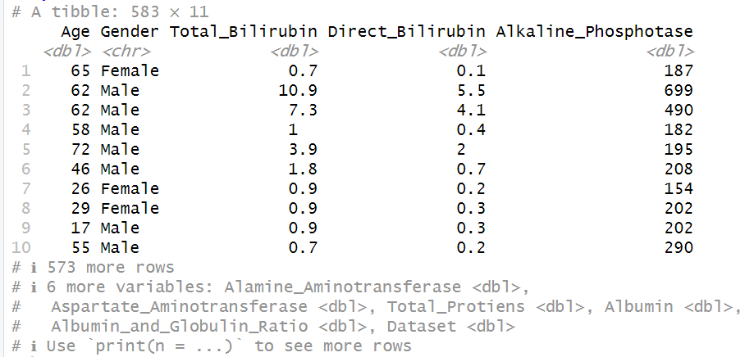This is the output of mydata and shows that initially the tibble (tidy table) consists of 583 instances (rows) and 11 attributes (columns/variables). It also outlines only the first 10 rows and the data types for each variable. The above checks for the data types of each variable column clearly as also tests whether the input data types are consistent within each column, returning TRUE if true and vice versa, FALSE if any inputs do not match. It then also shows the dimensional size of the dataset at this stage.
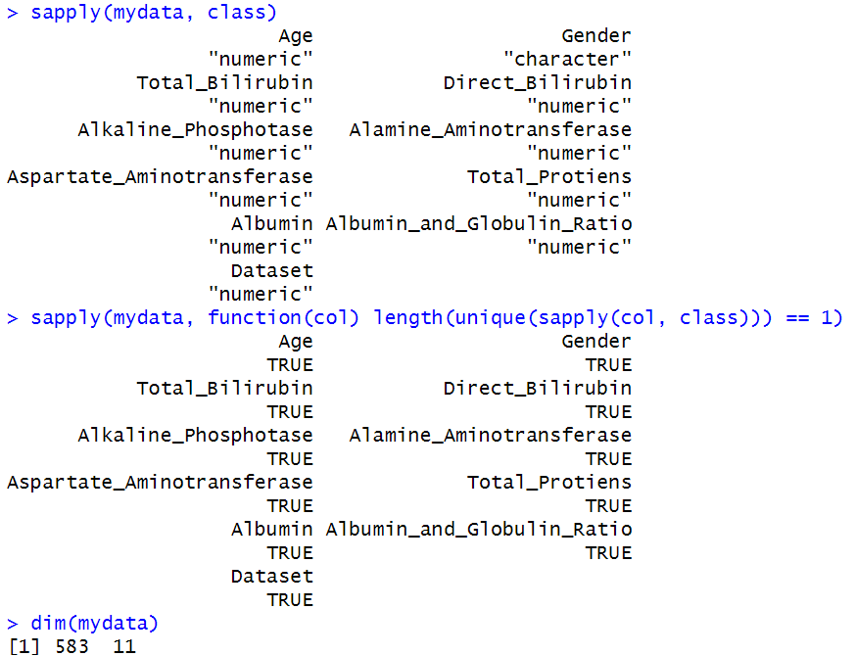
Is.na function checks how many input points are missing from the dataset and then after it deletes the rows where these are located. After checking the dimensions, it shows that the 4 rows have been removed from the dataset into a new tibble; 579 rows of data remain.
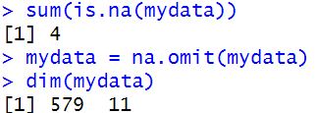
The code identifies any duplicated rows with the exact same data points. It then goes through the dataset and removes these columns, leaving behind a remainder of 566 rows. However, a disclaimer is that it is assumed that these duplicates are miswritten inputs and not that multiple patients had identical medical records. This idea can only be confirmed by contacting the place of origin for the data.
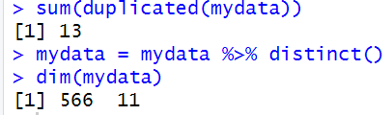
mydata = mydata %>%
mutate(mydata, Globulin = Albumin * Albumin_and_Globulin_Ratio)
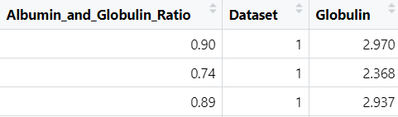
Adds a column on end as a right join called Globulin that is calculated from the Albumin and Globulin Ratio and Albumin variables of each row.
mydata = subset(mydata, select = -Dataset)

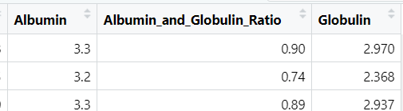
Deletes the Dataset column leaving the actual dataset with 11 columns like the original.
exclude_col = c("age")
check = setdiff(names(mydata)[sapply(mydata, is.numeric)], exclude_col)
is_outlier = function(out) {
q1 = quantile(out, 0.25, na.rm = TRUE)
q3 = quantile(out, 0.75, na.rm = TRUE)
iqr = q3-q1
out <(q1-1.5*iqr) | out > (q3+1.5*iqr)
}
out_matrix = sapply(mydata[check], is_outlier)
rows_with_out = apply(out_matrix, 1, any)
mydata_cleaned = mydata[!rows_with_out, ]
dim(mydata_cleaned)
-
This section of code assigns the Age column to be excluded from use in the function. Checks if the columns needed have numeric data type entries. The outlier function then calculates the lower and upper quartiles of the data to find the interquartile range. Anything within 1.5 if the interquartile range above the upper quartile and below the lower quartile is then considered to be an outlier; assuming these outliers are genuine mistypes and not patients with severe liver problems. After the data has been fully cleaned, it leaves the table with 376 instances and the following 11 attributes:
Age, Gender, Total Bilirubin, Direct Bilirubin, Alkaline Phosphotase (ALP), Alamine Aminotransferase (ALT), Aspartate Aminotransferase (AST), Total Protiens, Albumin, Albumin and Globulin Ratio and Globulin.

Data Visualization & Descriptive Analysis
Data visualization is the act of presenting large amounts of data in an easily understandable format and analysis explains the relationships within the dataset and what it means (Lau & Pan, n.d.).

Steps
- Define purpose: Ensuring what direction to follow when providing analysis of data and its visualization in aid.
- Identify correct dataset: Choosing the right dataset, making sure data is cleaned, accurate and consistent.
- Analyzing results: performing EDA (exploratory data analysis) to identify trends, patterns/correlations and detecting any anomalies.
- Designing, choosing and creating best visualizations: Helpful to convey a smooth understanding of the data to external people.
(Lau & Pan, n.d.)

Practical
The summary presents the averages and quartiles and descriptive points about the data. The standard deviation of roughly 16.8 years shows a low spread in age from the mean value. The average liver patient is 45 years old, the lowest is 4 years and the oldest is 90 years old. This shows that most patients who need to have their liver conditions monitored are mostly middle aged.
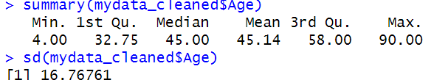
boxplot(mydata_cleaned$Albumin_and_Globulin_Ratio, horizontal=TRUE, col='#00FF00', main = "Boxplot")
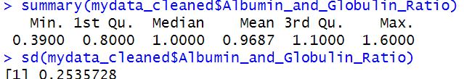
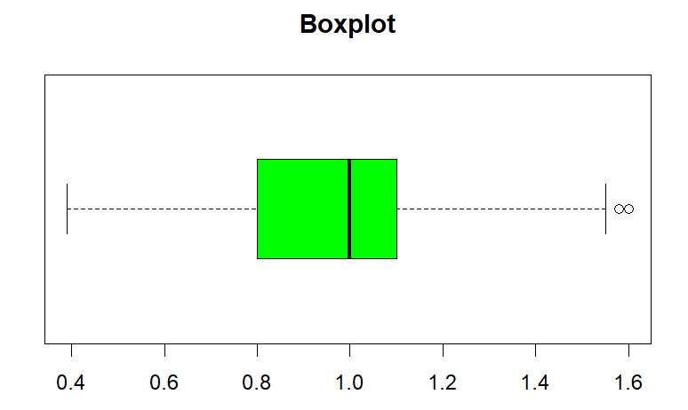
The univariate boxplot shows an easy visual representation of the statistical data of the albumin and globulin ratio. This shows that the mean ratio is 1:1, the minimum is 1:0.39, the maximum is 1:1.6. The data points within the green section also highlights the interquartile range. This could show that the range for the acceptable ratio is quite small for patients. Using the ggplot library, this creates an advanced, bivariate line graph with two types of instances in the Gender attribute. It plots the male and female frequencies, of ages that are used for the cleaned dataset.
library(ggplot2)
ggplot(mydata_cleaned, aes(x = Age, color = Gender)) +
geom_line(stat = "count") +
labs(y = "Frequency", title = "Frequency of Age, by Gender")
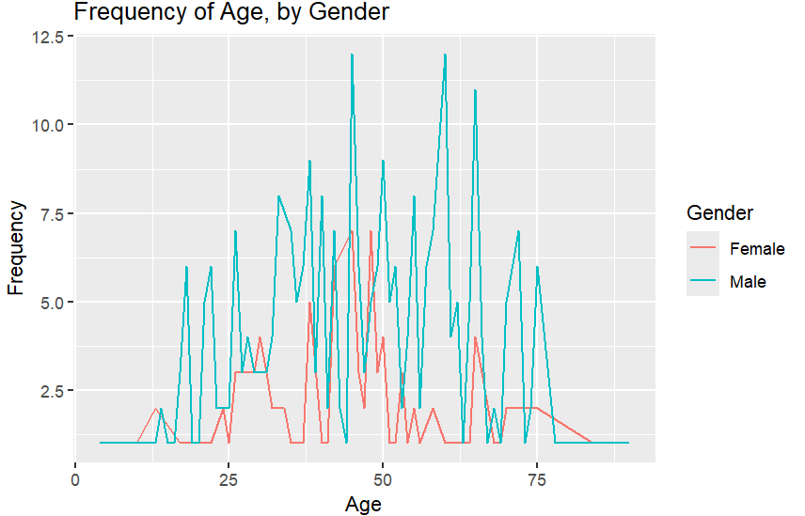
By comparison, it is accentuated that more male patients are admitted than females, as well as a higher frequency of men after the age of 45. For males, the skewness is a little bit more to the right, whereas for females, there doesn’t seem to be any skew, more representative of a normal distribution.
Produces a simple bivariate scatter graph comparing the Total Bilirubin and Direct Bilirubin.
ggplot(mydata_cleaned, aes(x = Total_Bilirubin, y = Direct_Bilirubin)) +
geom_point() +
labs(title = "Total vs Direct Bilirubi")
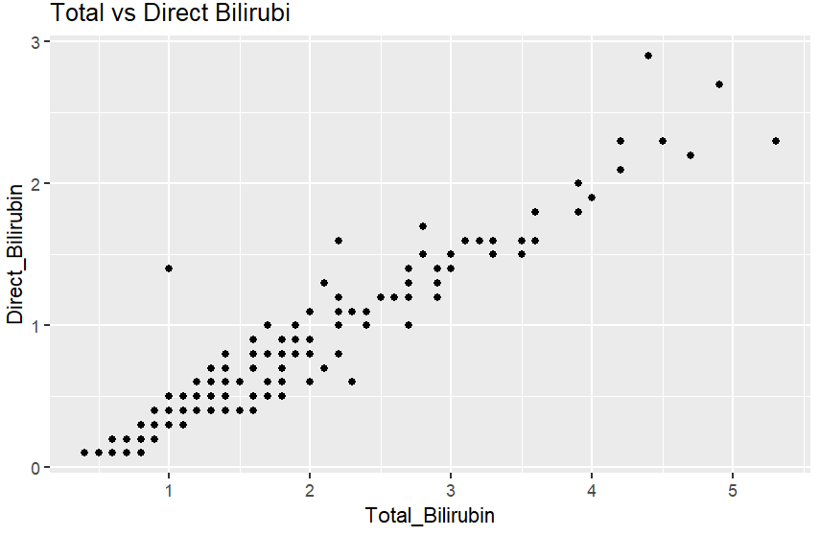
The graph shows a direct and strong positive correlation between the 2 factors. The data point marked in red can be labelled as an outlier, as it strays far away from the line of correlation. This observation may warrant further investigation as it deviates substantially from the overall pattern within the dataset.

This code produces a bar chart looking at the attributes: Alkaline Phosphotase (ALP), Alamine Aminotransferase (ALT) and Aspartate Aminotransferase (AST). It also assigns each a colour for better visualisation.
bar = mydata_cleaned %>%
select(Alkaline_Phosphotase, Alamine_Aminotransferase,Aspartate_Aminotransferase) %>%
gather(key = "Enzyme", value = "Value")
ggplot(bar, aes(x = Enzyme, y = Value, fill = Enzyme)) +
geom_bar(stat = "summary", fun = "mean") +
labs(title = "Comparison of ALP, ALT, and AST", x= "Enzyme", y= "Mean Value")
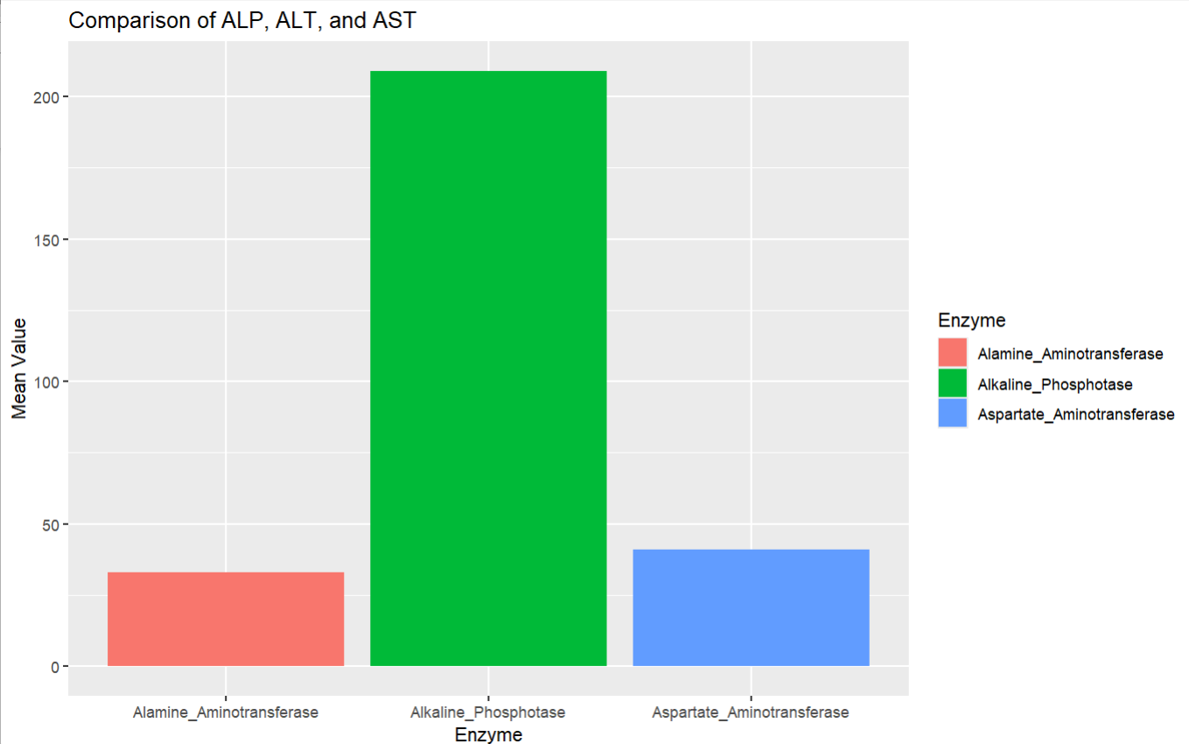The chart shows that ALP recorded the highest average value amongst the three enzymes analysed. Such comparisons can assist healthcare professionals in identifying unusual patterns within patient records and prioritising further investigation where appropriate.

Other
To review the findings of the visualization and analysis, the following are found:
- Shows that ALP recorded the highest average value amongst the enzymes analysed.
- There is a strong positive correlation between the total amount of Bilirubin and the direct amount.
- Middle-aged and older male patients accounted for a larger proportion of the records within the dataset.

The use of visual aid helps uncover hidden patterns or outliers (like it is shown with the scatter graph for Bilirubin), aiding decision making. Another is improving communication between the departments of the hospital, in this specific case, it will help bridge gaps between technical and medical staff, ensuring that the information is clearly relayed across the organisation. This factor also allows for there to be enhanced collaboration between the different departments, optimizing business processes. Lastly, it allows a company to have a competitive advantage over its competitors. Leveraging accurate analysis enables identification of growth opportunities and proactive response to risks.

Industry Application

Healthcare diagnostics & treatment
IBM Watson Health’s uses data science practices to provide personalized diagnostics and treatment recommendations. They also employ AI technology to automate the process of data preparation and cleaning, enhancing their employee work efficiency and Doctors’ informed decision making. Their key achievements are inclusive of; increased diagnostic accuracy, faster treatment planning and reduced medical errors, all enhancing patient safety and business processes that aid the hospitals strategy (Sharma, 2023).

Conclusion
In summary, this report has demonstrated how R programming can be effectively leveraged to streamline the data analytics pipeline, particularly in the context of healthcare data. Through data preparation and cleaning, the dataset was transformed into a reliable source for insightful analysis and visualization. The visualizations then revealed key trends, such as strong correlations between clinical results of Bilirubin, which can directly inform medical decision-making and resource allocation. By integrating these data science practices, organizations can enhance their IT management decisions, support the development of predictive models, and ultimately gain a competitive advantage. As seen in the medical industry like IBM Watson Health, the incorporation of AI technology highlights the importance of automated data processing to enhance diagnostic accuracy and operational efficiency. Overall, data science supports an organization's business strategy through the positive effects of it on decision making and business processes.

Key Takeaways
This project provided practical experience in applying data analytics techniques to a healthcare dataset using R. Through data cleaning, transformation, exploratory analysis, and visualisation, the project demonstrated how analytical workflows can be used to produce meaningful insights from raw data.
The project strengthened skills in data quality assessment, statistical analysis, data visualisation, and communicating findings through technical reporting. Future enhancements could include predictive modelling and the development of interactive dashboards to support deeper analysis.

References
Cotton, R. (2022, June 3). R Basics Cheat Sheet. Www.datacamp.com. https://www.datacamp.com/cheat-sheet/getting-started-r
Kabacoff, R. (2023). Chapter 1 Introduction | Modern Data Visualization with R. Github.io. https://rkabacoff.github.io/datavis/Intro.html#prequisites
Lau, G., & Pan, L. (n.d.). A 5-step guide to data visualization. https://health.usf.edu/-/media/v3/usf-health/medicine/Internal-Medicine/IMpact/Files/a-5-step-guide-to-data-visualization.ashx
Rao, S. (2023, August 29). The Quick and Easy Guide to Data Preparation. FirstEigen. https://firsteigen.com/blog/data-preparation/
Sharma, A. (2023, September 11). 10 Real-World Data Science Case Studies Worth Reading. Www.turing.com. https://www.turing.com/resources/data-science-case-studies
Tableau. (2024). Data cleaning: the Benefits and Steps to Creating and Using Clean Data. Tableau Software. https://www.tableau.com/learn/articles/what-is-data-cleaning

